The following plots are of a 1.7 MHz HP filter cascaded with Low Pass Filters from QRP-Labs. These filters are plugged into the kitset mother board which contains the switching relays etc. Hans Summers has documented the performance of the individual filters and evaluated the toroids used https://qrp-labs.com/images/lpfkit/toroid.pdf so a good idea of how the response is affected by cascading can be seen. The HP Filter is mounted on a single PCB on the underside of a horizontal partition in a metal case and the LP Filter is mounted on the upper side of the partition.

Below is a copy of the post to the Hermes-Lite Group where I published the plots

https://groups.google.com/forum/?fromgroups=#!topic/hermes-lite/AaX0BLAPdKY

Hello Jim,
Very interesting experiments with even more useful results. Using a mixture of filter types to get appropriate inductors is a novel and practical idea. The big disadvantage of Cauer and Tonne filters is that different values are needed for the inductors which makes it hard to design from the limited range of the devices available but if a pair can be found the Cauer gives the best result. You have alluded elsewhere that the Tonne is not a good candidate for switched cascaded filter sets as it has a slight bandpass characteristic. I have included plots of the filter set that I am currently using on my HiQSDR on the output of my home brew 10 watt amp. Again I am sorry but they are only Toroids used there but they do give an indication of how the filter set performs and that there is no worries about wild input or output impedances as the S11 plots show.
I just have to mention Jim that your gift to the ham radio community of your Quisk VNA has enabled me to do work with filters that I could never have achieved any other way and I am very grateful.
73, Graeme zl2apv

Plot 1.
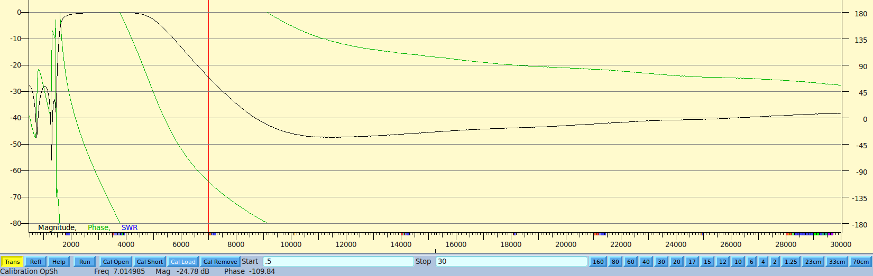
1.7 MHZ HP Filter cascaded with a 4 MHz Low Pass filter in transmission mode

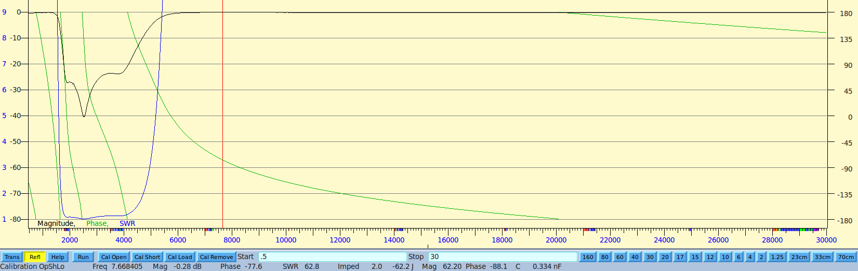
1.7 MHZ HP Filter cascaded with a 4 MHz Low Pass filter in reflection mode
Plot 2.
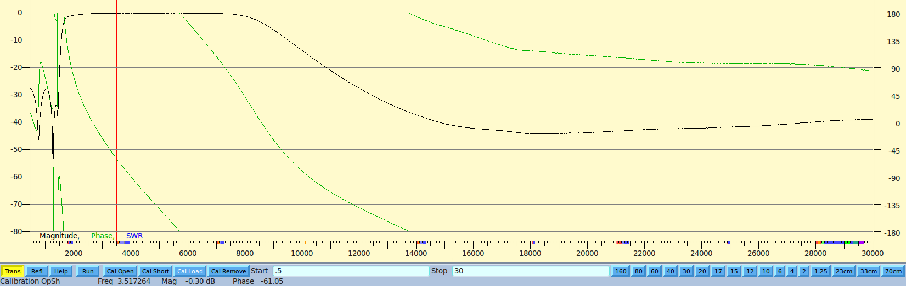
1.7 MHZ HP Filter cascaded with a 7 MHz Low Pass filter in transmission mode

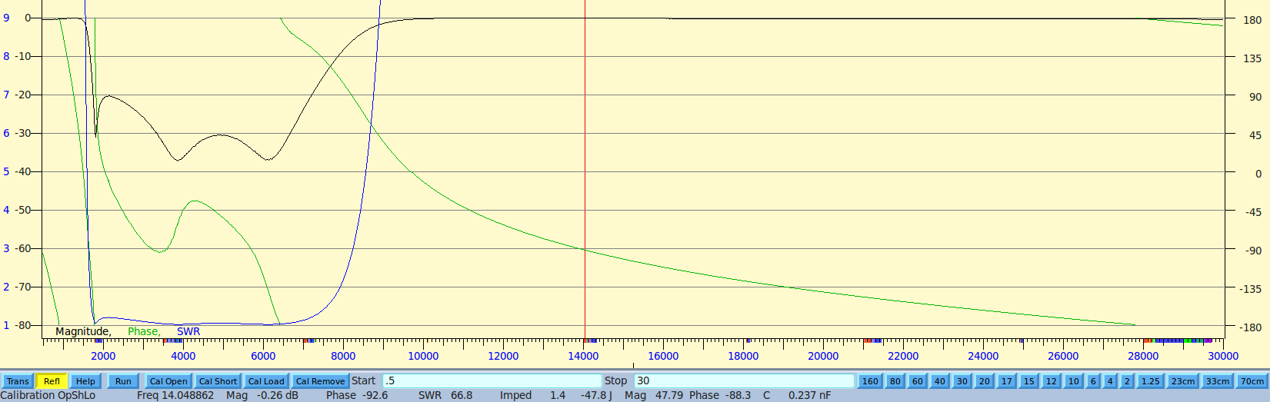
1.7 MHZ HP Filter cascaded with a 7 MHz Low Pass filter in reflection mode
Plot 3.
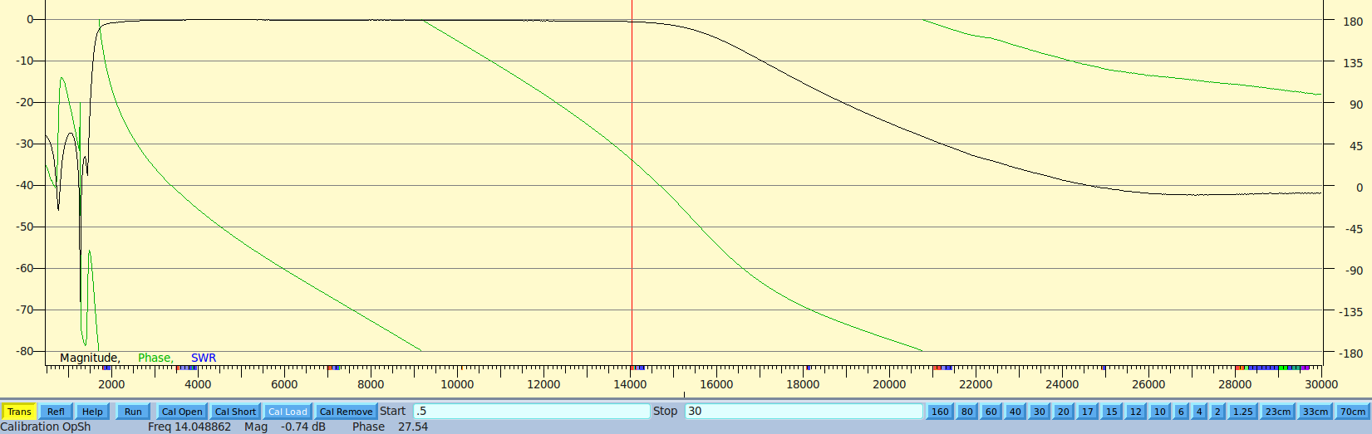
1.7 MHZ HP Filter cascaded with a 14 MHz Low Pass filter in transmission mode

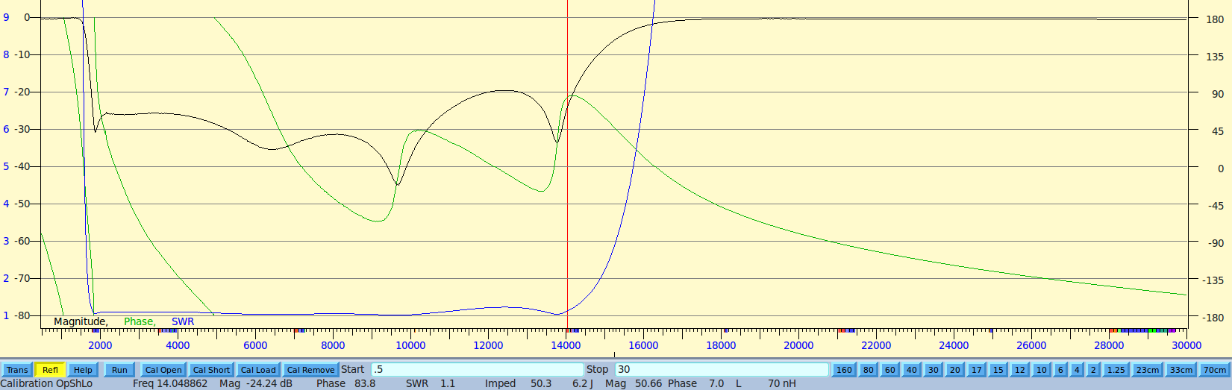
1.7 MHZ HP Filter cascaded with a 44 MHz Low Pass filter in reflection mode

